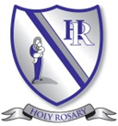
Religious Education Newsletter
September - October 2026: Creation and Covenant
The information below provides an overview of the first R.E. branch, Creation and Covenant, which is being taught from EYFS to Year 6 during the first half of the Autumn term. We encourage you to spend time talking with your child about what they have been learning and to support them with the suggested ‘Learning at Home’ activities. We would love to see these activities shared on Class Dojo pages.
Please see Our Catholic Life page on our website and check out our class and whole school pages on Class Dojo to see the wonderful Religious Education work produced by your amazing children and to discover how we live out our mission statement each day:
‘Together as a family, we love, learn and grow in the presence of God.’
EYFS
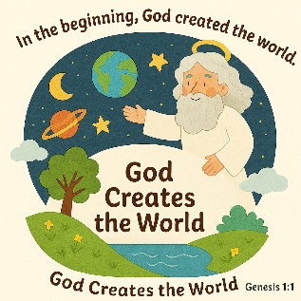
During the first branch, children in EYFS will learn that God lovingly created the world and that everything he made is good and special. They will listen to and explore scripture from Genesis, hearing the story of creation and discovering how God cares for all people and for the world. Through stories, play, prayer and reflection, children will learn that they are loved by God and can show care for others and for creation too.
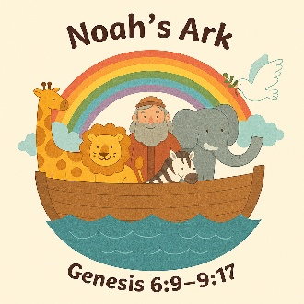
YEARS 1 AND 2
Our Year 1 children will learn that God created the world out of love and that all creation is precious. They will listen to scripture from the Book of Genesis about the creation of the world and will learn that everything God made is good. Through prayer, storytelling and discussion, children will explore how they can care for God’s world and one another. In Year 2, children will deepen their understanding of God as creator and learn about the special promises God makes. They will listen to the story of Noah and the rainbow which teaches them about God’s covenant of love and care. They will reflect on how they can respond to God’s promises by making good choices and looking after creation and others.
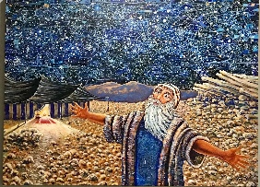
YEARS 3 AND 4
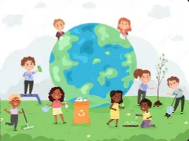
In Year 3, children will explore what it means to believe in God as the creator and how creation shows God’s love and care for everyone. They will listen to scripture from the Book of Genesis, focusing on the creation stories and what these teach us about God and humanity. They will reflect on their role in caring for the world and living as an integral part of God’s creation. Year 4 will learn about God’s promises and the special relationship that he forms with his people. They will also listen to scripture from Genesis, particularly the story of Abraham, and explore how God makes a covenant and remains faithful to his promises. Children will consider how trust and faith are important in their own relationships with God and others.
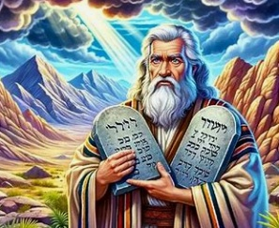
YEARS 5 AND 6

During this branch, Year 5 and Year 6 pupils will deepen their understanding of covenant as a way God guides people in how to live good and faithful lives. They will listen to the story of Moses and the Ten Commandments and will reflect on how God’s laws help people to make moral choices and take responsibility for their actions. The children will begin to explore the deeper meaning of creation and humanity’s responsibility within it. Pupils will reflect critically on how they are called to live justly, care for creation and respond to God’s call in the modern world.

HOME LEARNING ACTIVITIES
- Go for a walk and notice different parts of God’s creation (plants, animals, sky, people). Encourage your child to say or write a short prayer thanking God for one thing they noticed.
- Create a collage or model showing something God created (the world, animals, oceans, people) then add a sentence explaining why it is special and how they can care for it.
- Watch a YouTube clip from the Bible (such as Genesis or Noah’s story) and talk about what it teaches us about God’s love and promises.
- Choose one way to care for God’s world at home—recycling, saving water, turning off lights or helping in the garden.
- Talk about what a promise or covenant means and create a simple promise chart showing one promise they will try to keep (e.g. being kind, helping others, caring for creation).

