HOLY ROSARY CATHOLIC PRIMARY SCHOOL
“Together as a family, we love, learn and grow in the presence of God”
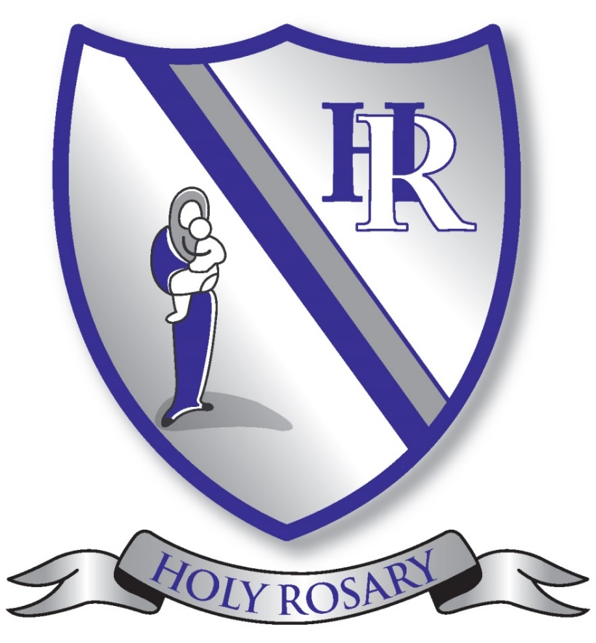

Prayer and Liturgy Policy 2026-27
Chair of Governors | Msgr Philip Inch
Headteacher | Mrs M Stevenson
Subject Leaders | Mrs G Oldfield, Mrs A Casey
Review Date | Summer 2027
Holy Rosary Mission Statement
Together as a a family, we love, learn and grow in the presence of God

Contents
1. The context of the ‘Prayer and Liturgy’ policy
2. Statement of Requirement
3. Roles and Responsibilities
4. Overview of ‘Prayer and Liturgy’ provision
4.1 Year Groups
4.2. Reception
4.3. Key Stage 1 (Year 1 – 2)
4.4. Key Stage 2 (Year 3 – 6)
5. Resources and Resourcing
6. Monitoring, Evaluation and Review
7. Links with the Community Training and Formation
Appendices
Appendix 1: Annual Prayer and Liturgy Provision
Appendix 2: Termly Prayer and Liturgy Provision
Appendix 3: Prayer of the Month Timetable-------------
Appendix 4: Prayer

1. THE CONTEXT OF THE PRAYER AND LITURGY POLICY
‘The celebration of Catholic liturgies and prayers as an integral part of the learning and
teaching should:
• enable the school community to become reflective
• experience the presence of God
• develop a mature spiritual life

2. STATEMENT OF REQUIREMENT
The law requires all maintained Catholic schools to provide an act of daily collective
worship (‘Prayer and Liturgy’) for all pupils, (Section 70, 1988 Education Act) that is in
accordance with the rites, practices, disciplines, and liturgical norms of the Catholic
Church (School Standards and Framework Act 1988, schedule 20; Instrument of
government, clause 2).

The law requires all maintained schools to recognise and respect that parents have the
legal right to withdraw their children up to the age of 16 from ‘Prayer and Liturgy’ (School
legal Standards and Framework Act 1988, s.71(1A).
The school’s provision for ‘Prayer and Liturgy’ will fulfil pupils’ entitlement to experience
the range of liturgical treasures of the Church, including a shared repertoire of ‘Prayer and
Liturgy’ music with which pupils in the school will be familiar.

‘Prayer and Liturgy’ is not designated curriculum time. In the context of the Catholic
school, this means that times of prayer and liturgy are not considered to be part of the
allocation of curriculum time for Religious Education.

3. ROLES AND RESPONSIBILITY
3.1. Governance
The Governors, as guardians of the Catholic school’s life and mission, have a responsibility
to ensure that:
• ‘Prayer and Liturgy’ are central to the Catholic life of the school and therefore are
in line with the guidance set out by the ‘Prayer and Liturgy’ Directory;
• there is a named person who is responsible for ‘Prayer and Liturgy’ in the school
(Prayer and Liturgy Coordinator); Mrs Gemma Oldfield
• there is a named Governor who is responsible for ‘Prayer and Liturgy’ within the
Governing Body: Father Philip
• the ‘Prayer and Liturgy’ policy is updated regularly and shared with appropriate
stakeholders;
• there is a budget for ‘Prayer and Liturgy’ that reflects its centrality to the life of a Catholic School

3.2. Headteacher
The Headteacher, as the spiritual leader of the school as a Catholic community, ensures that:
• Prayer and Liturgy are central to the Catholic life of the school and therefore are in
line with the guidance set out by the Prayer and Liturgy Directory;
• they work in partnership with the leader for ‘Prayer and Liturgy’;
• those responsible for ‘Prayer and Liturgy’ in the school have been given appropriate
training and formation to ensure that all guidance is followed and adhered to;
• there are suitable resources for ‘Prayer and Liturgy’ in the school.

3.3. Prayer and Liturgy Coordinator
Those responsible for ‘Prayer and Liturgy’ ensure that:
• ‘Prayer and Liturgy’ are central to the Catholic life of the school and therefore are
in line with the guidance set out by the Prayer and Liturgy Directory;
• there is an Annual and Termly Plan of Provision for ‘Prayer and Liturgy’ across the
school year, which identifies liturgical seasons and key celebrations, as well as
opportunities for the celebration of the Sacraments;
• there is a daily planned prayer for all pupils, appropriate to age and ability, as
outlined in the Prayer and Liturgy Directory;
• pupils are supported in their liturgical formation to take an active role in the
planning, preparation, and delivery of ‘Prayer and Liturgy’ according to their age
and capacity; and in the manner which facilitates their progressive participation;
• resources to support the planning of ‘Prayer and Liturgy’ are appropriate and readily
available to staff and pupils;
• induction on ‘Prayer and Liturgy’ takes place for new members of staff as required;
• staff have access to effective training and formation opportunities;
• monitoring and evaluation of ‘Prayer and Liturgy’ take place regularly and feedback
into planning for future liturgies;
• monitoring of ‘Prayer and Liturgy’ is reported to the headteacher and Governing
Body to support whole-school development and the Catholic life of the school;
• there is collaboration with local clergy (Father Philip) and parish (Holy Rosary )
• liaison with the Diocesan Advisory Service and others is maintained to ensure they
keep updated with best practice.

OVERVIEW OF PRAYER AND LITURGY PROVISION
4.1. Year Groups
Celebration of the Word at Holy Rosary includes:
*Reading of scripture
It may also include:
*prayers - said all together or by individual pupils, written by the celebration lead or by the children, in response to the scripture focus or theme
*music, film, drama, art *sacred silence *traditional prayers *hymns and songs
4.1.1 Reception
After the first half term, children in Reception begin to attend some assemblies
Alongside the whole school and take part in acts of worship. In the Spring and summer terms they participate in an Easter assembly with KS1; they come to Church with the rest of the school for the May Procession and begin to attend weekly Celebration of the Word.
Each week, classes have individual acts of worship hosted inside their classrooms.
These are led by teachers with participation from pupils.

4.1.2 Key Stage 1 (Years 1 and 2)
Tuesdays- Celebration of the Word (this may include key celebrations in line with the liturgical year- scripture often taken from Sunday's readings; Picture News- sharing what is in the news from a particular perspective; Cafod...)
Fridays- Commendation Assembly (Collective Worship with a celebration
of pupils' weekly achievements) Including prayer.

Duration: approx. 20 mins

4.1.3 Lower Key Stage 2 (Years 3 and 4)
Tuesdays- Celebration of the Word (this may include key celebrations in line with the liturgical year- scripture often taken from Sunday's readings; Picture News- sharing what is in the news from a particular perspective; Cafod...)
Duration: approx. 20-25 mins
Fridays- Commendation Assembly (with UKS2) (Collective Worship with a celebration
of pupils' weekly achievements) Including prayer.

4.1.4. Upper Key Stage 2 (Years 5 – 6)
Mondays : Celebration of the Word (including key celebrations in line with the liturgical year- scripture often taken from Sunday's readings; Picture News- sharing what is in the news from a particular perspective; Cafod...) includes Hymns
Fridays: Commendation Assembly (Collective Worship with a celebration of pupils' weekly achievements) Including prayer

Duration: approx. 25-30 mins

4.2. WHEN
Worship takes place daily in each class:
- at the beginning and end of each day
- before and after lunch
- classroom worship
- during assemblies

We have special acts of worship:
Advent and Lent
Christmas and Easter; May Procession
Special circumstances – CAFOD, Remembrance Day, Candlemas; Pentecost
RED Class Curriculum Celebrations of the Word, shared with parents
Catholic Social Teaching

We celebrate Mass when possible:
• Holy Days of Obligation
• Beginning of the school year (linked to the Feast of the Holy Rosary)
• End of the school year (Leavers)
• Sometimes we hold class masses (Summer term)
• Special circumstances/anniversaries; staff masses

4.3. LOCATIONS

Our acts of worship take place in:
- classrooms
- school hall
- Church
- school field
- prayer gardens
- Poly tunnel
- Prayer room and prayer tables around the school building: opportunities for individual and spontaneous prayer

4.4. PRAYER
The hall and each classroom have a focus area for prayer.
Prayer can be vocal, contemplative, and meditative.
Children are taught many prayers during their time at school and by the end of Key Stage 2,
we would expect our children to know the prayers stated in the Religious Education
Directory. Children are given Prayer booklets for school and home ------(EYFS, KS1, LKS2 and UKS2). The children are taught the meaning of each prayer, which is displayed in the classroom and prayed regularly.

There is a prayer, written by the staff and children, for each curriculum subject.
Children are also encouraged to pray in their heart during quiet or reflective times.
In class, children have the opportunity to compose their own prayers and share with others if they wish.
We also pray when we sing and once a week, when we gather together to sings hymns and listen to music; in Celebration of the Word and in Assemblies.

4.5. STRUCTURE
We endeavour to include a balance between:
• scriptures
• prayers,
• stories,
• drama,
• silence,
• meditations and songs

This is whilst listening, responding, thinking, and sharing.
5. RESOURCES AND RESOURCING
We use a range of resources to enhance prayer and liturgy throughout the school including artefacts, books, posters, visitors, consumables, natural world items.
‘Prayer and Liturgy’ is central to the school’s understanding of itself as a Catholic school and this is reflected in the annual budget allocation and available resources, including staff time and dedicated spaces for ‘Prayer and Liturgy’. (Prayer focus areas; prayer gardens outside, prayer room...)
The Catholic character of the school is reflected in the religious artifacts and images on
display throughout the building. Dedicated displays, prayers and scripture quotes are also prominent and enhance the Catholic character of the school.
Dedicated spaces for ‘Prayer and Liturgy’ are appropriately furnished and maintained; and
updated to reflect the church’s liturgical season.
Staff training and formation costs will be funded separately to ensure that the staff are able to fulfil their responsibility to contribute to the prayer and liturgical life of the school.

MONITORING, EVALUATION AND REVIEW
The Religious Education Co-ordinators are responsible for carrying out monitoring in accordance with the school’s policies.
Monitoring and evaluation of the quality and impact of ‘Prayer and Liturgy’ will take place
regularly, and at least annually. It will involve all key stakeholders: pupils, parents, staff,
clergy, and governors. Areas for development will be identified and issues raised will be
actioned and evidenced as appropriate.
The policy will be reviewed as part of the regular cycle of policy review.

LINKS WITH THE COMMUNITY
Parents are invited to many of our acts of worship such as Stay and Pray, class branch celebrations, school masses and reconciliation services. The school supports and actively fundraises for CAFOD, the Good Shepherd, Zoe’s Place, Alder Hey, Mary’s Meals, the local food bank. Pupils' input is instrumental in selecting some of the charities which we fundraise for and much of our charity work is initiated by the children.
TRAINING AND FORMATION
All new staff will be supported during induction and beyond, so that they fully understand the responsibility they carry within their individual role for leading ‘Prayer and Liturgy’ in the school. Any individual training needs will be identified and addressed through training and formation. There will also be the opportunity for whole-staff professional development at least once a year, so that all staff understand the importance of ‘Prayer and Liturgy’ and relevant staff are well supported to lead as required.
RE including ‘prayer and liturgy’ as standing agenda items on the class teachers and staff meeting agendas.

Appendix 1 and 2: Annual plan of provision 2025-26,
including termly breakdown
Autumn term
Mass for the Feast of the Holy Rosary - in Church-----October 7th 2025
Prayer and Liturgy celebration, Y6 with Maricourt----October 9th 2025
Mission Day ----October 20th 2025
J6 Come and See Celebration with parents- October 2026
J5 Come and See Celebration with parents- November 19th
Jubilee Celebration Day- Pilgrims of Hope---November 21st 2025
Advent Service LKS2- in Church ---- December 4th 2025
Christingle Service – Year 1
Y2 Liverpool Cathedral Visit- December 10th 2025
EYFS and KS1 Nativity 8th- 12th December 2025
UKS2 Christmas Service- in Church - December 18th 2025

Spring Term
Feast of the Epiphany – Celebration -January 6th 2026
Ash Wednesday- Fr Philip to come in to school- February 18th 2026
Stations of the Cross- LKS2 – in Church March 23rd 2026
Mission Day- March 24th 2026
Y2 Singing with the Archdiocese at Holy Rosary Church- Jonah and the Whale
J4 RED Branch Celebration of the Word- with parents
J3 RED Branch Celebration of the Word- with parents

Summer
Easter Service -UKS2- in Church- April 14th 2026
Reconciliaton- Y4- in Church with parents
Holy Communion preparation- in Church - May 1st 2026
Reception visit to Church – May 15th 2026
Pentecost celebration –Y2 May 26th 2026
May Procession- Rec-Y6- process to Church- May 22nd 2026
J2 RED Branch celebration of the Word- with parents
J1 RED Branch Celebration of the Word- with parents
Y1 Singing with the Archdiocese at Liverpool Catholic Cathedral
Walk of Faith- Liverpool- Fr Philip, KS2 RE Ambassadors and Mrs Casey- visit Liverpool Catholic Cathedral, celebrate Mass- said by Fr Philip in the Crypt, then visit Anglican Cathedral
Walk of Faith – Aintree- Fr Philip, KS1 and KS2 RE Ambassadors and Mrs Stevenson- visit St Giles, Hope Centre, Methodist Church and Holy Rosary Church- July 13th 2026
Leavers' mass- Y6 children and parents- in Church- July 20th 2026

In addition: Prayer and Liturgy
Whole school:
- Weekly Celebration of the Word- led by Mrs Casey (Monday UKS2, Tuesday LKS2; then KS1)
- Celebration of the Word -Gospel celebration (Led by Mrs Casey)
- Praise Assembly (Collective Worship through Hymns) (Led by Mrs.Casey/Mrs. Stevenson)
- Weekly Merit Assembly (Collective Worship with a celebration of Weekly
Achievement) Led by Mrs Stevenson

Daily Prayer:
Morning, before lunch, after lunch (optional) and end of day prayers
Celebration of the Word (in class) at least once a week. These take place in class, in prayer gardens, in the poly tunnel, on the field… There will also be moments of spontaneous prayer and prayerful moments identified by teachers and shared with the children.

Appendix 3: Prayers for each year group
EYFS
The Sign of the Cross
Morning prayer
Lunch time prayer
Home time prayer
KS1
The Sign of the Cross
The Lord’s Prayer
Hail Mary
Glory be
Grace before meals
Grace after meals
Lower KS2
The Apostles Creed
An Act of Contrition
Angel of God
Come , Holy Spirit
The Prayer of St. Richard of Chichester
Upper KS2
Morning Offering
The Rosary
The Magnificat
Act of Faith
Act of Hope
Act of Love

Appendix 4
The Sign of the Cross
In the name of the Father and of the Son and of the Holy Spirit. Amen.
The Lord’s Prayer
Our Father who art in heaven, hallowed be thy name. Thy kingdom come, Thy will be done on earth, as it is in heaven. Give us this day our daily bread, and forgive us our trespasses, as we forgive those who trespass against us, and lead us not into temptation, but deliver us from evil.
The Hail Mary
Hail, Mary, full of grace, the Lord is with thee. Blessed art thou among women and blessed is the fruit of thy womb, Jesus. Holy Mary, Mother of God, pray for us sinners, now and at the hour of our death. Amen.
Glory be to the Father…
Glory be to the Father and to the Son and to the Holy Spirit, as it was in the beginning is now, and ever shall be world without end. Amen.
Grace before meals
Dear God, Please bless those who have prepared this meal and those who are about to eat it. We ask this through Jesus Christ Our Lord, Amen
Grace after meals
Thank you, God, for the food that we have eaten and enjoyed. May the sharing of this meal keep us always united in Jesus Christ, Your Son

Thank you, God, for all our friends Thank
you, God, for everything Thank you, God. Amen
The Apostles’ Creed
I believe in God, the Father almighty Creator of heaven and earth, and in Jesus Christ, his only Son, our Lord, who was conceived by the Holy Spirit, born of the Virgin Mary, suffered under Pontius Pilate, was crucified, died and was buried; he descended into hell; on the third day he rose again from the dead; he ascended into heaven, and is seated at the right hand of God the Father almighty; from there he will come to judge the living and the dead. I believe in the Holy Spirit, the holy catholic Church, the communion of saints, the forgiveness of sins, the resurrection of the body, and life everlasting. Amen.
Act of Contrition
O my God, because you are so good, I am very sorry that I have sinned against you, and with the help of your grace, I will not sin again.

Angel of God
Angel of God, my guardian dear,
to whom God’s love commits me here,
ever this day be at my side,
to light and guard,
to rule and guide. Amen.

Come, Holy Spirit
V. Come, Holy Spirit, fill the hearts of your faithful.
R. And kindle in them the fire of your love.
V. Send forth your Spirit and they shall be created.
R. And you will renew the face of the earth.
Let us pray
O God, who by the light of the Holy Spirit, did instruct the hearts of your faithful, grant that
by that same Holy Spirit, we may be truly wise, and ever rejoice in your consolation, through
Christ our Lord. Amen.
Prayer of St Richard of Chichester
Thanks be to you, my Lord Jesus Christ, for all the benefits which you have given me, for all the pains and insults which you have borne for me. O most merciful Redeemer, friend and brother, may I know you more clearly, love you more dearly, and follow you more nearly, day by day. Amen.
Morning Offering
O Jesus, through the most-pure heart of Mary, I offer you all my prayers, thoughts, works and sufferings of this day for all the intentions of your most Sacred heart.

The Rosary
For each mystery of the decade, one Our Father, ten Hail Marys and the Glory Be is recited
The Joyful Mysteries
(Recited Monday and Saturday)
The Annunciation (Luke 1:26–38)
The Visitation (Luke 1:39–45)
The Nativity (Luke 2:1–7)
The Presentation in the Temple (Luke 2:22–35)

The Finding in the Temple (Luke 2:41–52)
The Mysteries of Light
(Recited Thursday)
The Baptism of Jesus (Matthew 3:13–17)
The Wedding Feast of Cana (John 2:1–12)
The Proclamation of the Kingdom, with the call to Conversion (Mark 1:14–15; 2:3–12)
The Transfiguration (Luke 9:28–36)
The Institution of the Eucharist (Matthew 26:26–29)
The Sorrowful Mysteries
(Recited Tuesday and Friday)
The Agony in the Garden (Mark 14:32–42)
The Scourging at the Pillar (Matthew 27:15–26)
The Crowning with Thorns (Matthew 27:27–31)
The Carrying of the Cross (John 19:15–17; Luke 23:27–32)
The Crucifixion (Luke 23:33–38, 44–46)
The Glorious Mysteries
(Recited Wednesday and Sunday)
The Resurrection (Matthew 28:1–8)
The Ascension (Acts 1:6–11)
The Descent of the Holy Spirit (Acts 2:1–12)
The Assumption (1 Thessalonians 4:13–19)
The Coronation of Mary Queen of Heaven and Earth
(Revelation 12:1; 14:1–5; Isaiah 6:1–3)
Prayer concluding the Rosary
[Hail, Holy Queen, etc. as above]
V. Pray for us, O holy Mother of God.
R. That we may be made worthy of the promises of Christ.
Let us pray.
God, whose only-begotten Son, by his life, death and resurrection, has purchased for us the rewards of eternal life, grant, we beseech thee, that meditating on these mysteries of the most holy Rosary of the Blessed Virgin Mary, we may imitate what they contain and obtain what they promise, through the same Christ our Lord. Amen.
The Magnificat
My soul proclaims the greatness of the Lord, and my spirit rejoices in God my Saviour, for he has looked upon his handmaid in her lowliness; for behold, from this day forward, all generations will call me blessed. For the Almighty has done great things for me, and holy is his name. His mercy is from age to age for those who fear him.
He has made known the strength of his arm and has scattered the proud in their conceit of heart. He has cast down the mighty from their thrones and has exalted those who are lowly. He has filled the hungry with good things and has sent the rich away empty.
He has helped his servant Israel, mindful of his mercy, even as he promised to our fathers, to Abraham and his descendants for ever.
Glory Be
Glory be to the Father and to the Son and to the Holy Spirit, as it was in the beginning, is now, and ever shall be, world without end. Amen.

Act of Faith
My God, I believe in you and all that your Church teaches, because you have said it, and your word is true.
Act of Hope
My God, I hope in you, for grace and for glory, because of your promises, your mercy and your power.
Act of Love
My God, because you are so good, I love you with all my heart, and for your sake, I love your neighbour as myself.

