Holy Rosary Catholic Primary School

”Together as a family, we love, learn and grow in the presence of God"
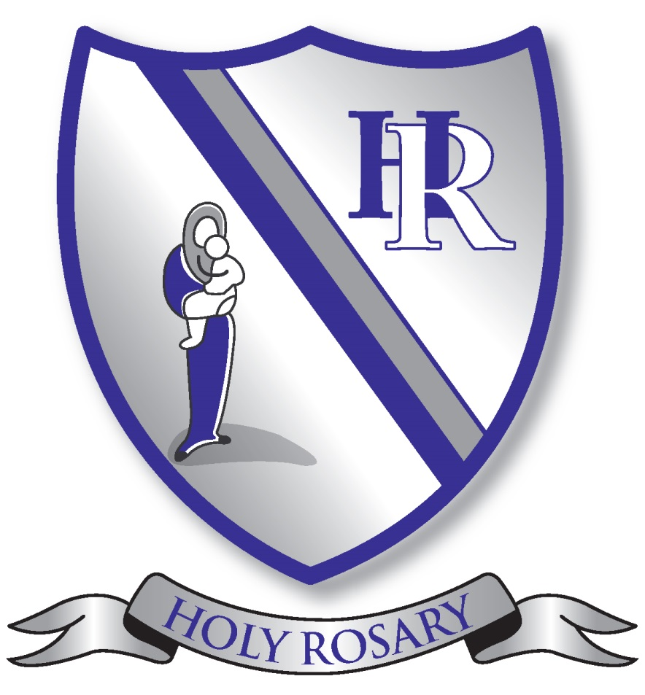

RE Handbook 2026-27

Chair of Governors | Msgr Philip Inch
Headteacher | Marianne Stevenson
Subject Leaders | Anna Casey, Sarah King
Review Date | Summer 2027

Our Mission Statement

”Together as a family, we love, learn and grow in the presence of God"

AIMS OF THE SCHOOL

To be a Christian community, living the Gospel values and fostering the spiritual, moral, personal and social development of all pupils.
Ways in which we may do this:
- Thorough planning for the delivery of ‘To Know You More Clearly’ and Come and See’
- Providing opportunities for meaningful collective worship, making use of reflection and having a prayer focus in each classroom
- Undertaking celebrations in school/church, which reflect the church year
- Providing a caring, sharing environment where staff lead by example in relationships and mutual respect
- Implementing a PHSE policy
- Providing training for lunchtime supervisors
- Involving all in mission statement reviews
- Providing "Rainbows for all God’s children" sessions for all those in need
- Ensuring anti-bullying, equal opportunities and behaviour policies are implemented and understood by all

To provide a broad and balanced curriculum which promotes high academic achievement and opportunities for pupils to develop as independent learners.
Ways in which we may do this:
- Providing children with opportunities to have fun and enjoy their learning
- Taking account of different learning styles
- Weekly planning which shows differentiated and well-suited tasks
- Employing skilled and dedicated personnel and giving them opportunities for CPD
- Having systems of assessment, monitoring and review to inform future planning
- Valuing and rewarding individual and team achievements
- Providing positive, consistent feedback with constructive comments for future targets
- Using a system to track pupil’s progress year on year, and using this information to improve performance
- Offering equal access to all activities without bias
- Offering opportunities for children to experience a range of ECA, trips and outside speakers
- Involving children in their own assessment/learning and evaluation processes
- Listening to the pupil/parent voice
- Developing creativity and promoting curiosity
- Providing active learning experiences and encouraging children to have a go
- Developing skills that will promote life-long learning

To promote good communication and trust between church home and the wider community.
Ways in which we may do this:
- Providing a welcoming, consistent, open door policy
- Encouraging parents and interested members of the community to become involved in the work of the school
- Holding information sessions for parents
- Providing information on pupil progress through annual reports and parents’ evenings
- Supporting charitable endeavours
- Promoting local community clubs
- Working with local church groups on community celebrations
- Supporting the parish priest and parishioners in sacramental programmes and other work of the parish
- Holding liturgical celebrations in church
- Working with Maricourt and other feeder schools for the benefit of all the children in the community
- Supporting and encouraging the "Friends of Holy Rosary"

To provide a safe, secure, healthy, stimulating environment in which pupils feel valued.
Ways in which we may do this:
- Providing well maintained and attractive buildings
- Ensuring health and safety procedures are understood and implemented by all
- Encouraging and reinforcing the need for pupils to have respect for property, resources and equipment and for the content and fabric of the building. This includes pupils' own property
- Establish an effective behaviour policy, with pupil input, based on rules, rewards and consequences
- Having a whole school approach to classroom routine
- Encouraging children to have the confidence to ask questions, raise issues and to feel their contributions are valued
- All staff and pupils showing respect, approachability and courtesy towards one another in their day to day relationships
- Valuing children’s work by celebrating it in many different ways

2. The General Norms
Article 2 – Aims of Religious Education
The aims of religious education are:
- To engage in a systematic study of the mystery of God, of the life and teaching of Jesus Christ, the teachings of the church, the central beliefs that Catholics hold, the basis for them and the relationship between faith and life;
- To enable pupils continually to deepen their religious and theological understanding and be able to communicate this effectively;
- To present an authentic vision of the Church’s moral and social teaching to provide pupils with a sure guide for living and the tools to critically engage wit contemporary culture and society
- To give pupils an understanding of the religions and worldviews present in the world today and the skills to engage in respectful and fruitful dialogue with those whose worldviews differ from their own;
- To develop the critical faculties of pupils so to bring clarity to the relationship between faith and life, and between faith and culture;
- To stimulate pupils’ imagination and provoke a desire for personal meaning as revealed in the truth of the Catholic faith;
- To enable pupils to relate the knowledge gained through religious education to their understanding of other subjects in the curriculum;

Article 3 – Outcome of Religious Education
The outcome of excellent religious education is religiously literate and consciously engaged young people who have the knowledge, understanding and skills – appropriate to their age and capacity- to reflect spiritually, and think ethically and theologically, and who recognise the demands of religious commitment in everyday life.
Article 4 – Religious Education as the heart of the curriculum
- Religious education is the core of the core curriculum and is to be the source and summit of the whole curriculum.
- Religious education is an academic discipline with the same systematic demands and rigour as other disciplines.
- Religious education is to be delivered within a broad and balanced curriculum, where it informs every aspect of the curriculum. Every other subject is to be informed by religious education and have a strong relationship with it.
- In each year of compulsory schooling, religious education is to be taught for at least 10% curriculum time within each repeating cycle of the regular school timetable.
3. The Religious Education Programme
To be fully compliant in fulfilling our aims and objectives we use the Scheme of Work recommended by the Archdiocese of Liverpool. All the content and expected outcomes are as outlined in the programmes of study for the various age groups in the Religious Education Directory – ‘To Know You More Clearly’ model curriculum as mandated by the Catholic Bishops’ Conference of England and Wales.

Overview of content
Come and See (Years 5 and 6) is developed through three themes based on the documents of the Second Vatican Council, which are gradually explored in increasingly greater depth. The themes are: Church, Sacrament and Christian Living. Each topic is presented through three sections: Explore; Reveal and Respond.
The Come and See topic overview can be viewed on our website under Catholic Life of the School- RE Teaching and Learning. In addition to learning about the Catholic faith, pupils also study other faiths including Judaism; Hinduism, Islam and Sikhism.
The Church theme occurs in each season and knowledge and understanding develops, building on understanding from the previous theme.
- Autumn – Domestic Church
- Spring- Local Church
- Summer- Universal Church
The Sacraments theme is planned in a similar way, building on prior learning:
- Autumn- Baptism
- Spring-Eucharist
- Summer- Reconciliation
The Christian Living theme is also planned across the seasons and builds on pupils’ prior knowledge:
- Autumn – Advent, Christmas
- Spring- Lent and Easter
- Summer- Pentecost
To Know You More Clearly (Years Nursery-Year 4)
The Spiral Curriculum

The spiral structure of the curriculum enables a build-up, layering a critical dimension each year, deepening pupils’ understanding of the story of salvation, developing a common language, and exploring the ‘memory of the Church’ and her teachings and how these have formed part of the history of ideas in the development of humanity.

The structure invites teachers to expose pupils to the beauty of Catholic Christianity and its shaping influence on culture through art, music, literature, science, and architecture historically and to the present day, which equips young people to dialogue with the beliefs and vision of the Church beyond intellectual remits and exposing them to the transcendent, a powerful pedagogy.

The spiral pathway students follow from their first steps into Catholic education means that teachers can plan for progression, moving through basic questioning and notional understandings to ever deeper levels of engagement with Christianity’s divine and human drama and its significance for humankind

The Curriculum Structures
The model curriculum has six components that will be known as branches.
Each one has a core theme and invites pupils to learn about an aspect of Revelation, Scripture, life in Christ, and life in the Church, and to discern what their learning means academically and experientially enabling them to see, judge, and act through a deeper knowledge of the Christian faith.

Branch 1 Creation and covenant: ‘The heavens are telling the glory of God’ (Ps 19:1)

• In this branch, pupils will encounter the God who creates and calls a people.
• They will explore revelation of the Christian belief that all that is comes from God, the Creation accounts in Genesis, and scientific explanations of the process of Creation.
• They will explore the call of God and his covenantal relationship with his people first through Abraham and Moses, then through the narrative of the Old Testament.

Branch 2 Prophecy and promise: ‘In many and various ways, God spoke to our ancestors by the prophets’ (Heb 1:1)

• In this branch, pupils will learn that the prophets speak of God reaching to his people, calling them back into a relationship with him.
• In this branch, pupils will explore the Christian understanding of the teaching of the prophets as they point to the fulfilment of God’s promise in a messiah, Jesus Christ.
• They will explore the expectant waiting for the Messiah through the Advent season and how this speaks to Christians today as they wait for Christ.
• Pupils will encounter the story of the nativity of Jesus and the mystery of the incarnation.

Branch 3 Galilee to Jerusalem: ‘God’s only Son, who is at the Father’s side, has made him known’ (Jn 1:18)

- In this branch, pupils will experience the ministry of Jesus, the Word of God.
- They will learn about the life of Jesus and his revelation of the Kingdom of God through parables, encounters, miracles, and teachings.
- They will learn about the call of the disciples and the nature of being a follower of Jesus.

Branch 4 Desert to garden: ‘Christ died for our sins in accordance with the scriptures, and that he was buried, and that he was raised on the third day’ (1 Cor 15:3)

• In this branch, pupils will study the season of Lent and its culmination in the events of Holy Week.
• They will learn about the Paschal Triduum at the heart of the Catholic Church’s Liturgy and life.
• The title of this branch points both to the liturgical journey from the desert of Lent to the garden of
Resurrection, but also to the Paschal journey from darkness to light, barrenness to fruitfulness, death to life.

Branch 5 To the ends of the Earth: ‘Go, therefore and make disciples of all nations, baptising them in the name of the Father and of the Son and of the Holy Spirit’ (Mt 28:19)

• In this branch, pupils will study the events that flowed from the Resurrection and Ascension in the coming of the Holy Spirit and the work of the apostles and early Church.
• They will also learn about the Catholic Church today as the apostolic Church and how its liturgy and structures flow from the early Church.

Branch 6 Dialogue and encounter: ‘For “In him we live and move and have our being”’ (Acts 17:28)

• In this branch, pupils will learn how Christians work together with people of different religious convictions and all people of goodwill towards the common good, respecting the dignity of all humanity.
• They will also encounter other pathways of belief drawing on the teaching of the Church about intercultural dialogue.

- The Approach Chosen

Knowledge Lenses – set out the object of study for pupils, they indicate what should be known by the end of each age phase:
The study of the Catholic Religion
- Hear
- Believe
- Celebrate
- Live

The study of other Religions and Worldviews
- Dialogue
- Encounter

The Sacraments – these are taught within and across branches. Pupils encounter scripture and what the Church teaches about scripture and what this means for a life lived in Christ as part of the Catholic faith.

The approach taken should encompass a variety of teaching and learning styles, which enable the needs of individual pupils to be met though a broad and balanced, cross-curricular, creative lessons.

Ways of Knowing – set out the skills that pupils should be developing as they progress through their curriculum journey. The three ways of knowing are: understand, discern, and respond.
5. Planning
At Holy Rosary our approach to planning in Religious Education has been tailored to address the needs of pupils, staff in light of different starting points on the new curriculum
LONG TERM PLANNING
Long-term planning (Responsibility of SMT) Each class has its own long-term plan according to the programme of study for that particular year group. Teachers will allocate 10% of curriculum time for Religious Education. This does not include Prayer and Liturgy time. This is indicated on individual timetables and monitored termly by SMT and RE link Governor.
MEDIUM-TERM PLANNING (Responsibility of RE Leads)
The R.E Coordinator will provide each class teacher with topic planning provided by the Archdiocese, in conjunction with topic overview mats outlining key learning from the RED (Hear, Believe, Celebrate, Live, Dialogue and Encounter). This will indicate the topics to be covered, the start and finish dates for RED/Come and See, and any special events or feast days which occur during the weeks of the topic, including those from other faiths. This also includes liturgical colours for seasons and a Prayer and Liturgy Annual plan of provision.
SHORT-TERM PLANNING (Responsibility of individual teachers)
All class teachers will be provided with the Archdiocese planning for their topic which they will then use in conjunction with the topic :
- To attend half termly staff meetings- to come together as a staff, to reflect on the key focus of each branch, look at scripture and and share ways the learning will be delivered.
• To allocate time for each learning outcome to be achieved.
• To plan the topic to ensure achievement of the learning outcomes either by highlighting scripture and activities on the SOW OR completing a branch learning overview.
• To select appropriate activities for the whole class or groups of children.
• To assess pupils through continuous informal on-going teacher assessment as pupils move through the branches.
RE Planning at Holy Rosary follows recommendations from Liverpool Archdiocese. As with other curriculum areas, there is no set planning format for RE lessons and teachers are free to organise their planning in whichever form is most helpful to them.
FOUNDATION STAGE APPROACH
Religious Education is at the heart of all areas of learning outlined in the curriculum for the Foundation stage,
The Foundation stage classes also keep evidence of their RE learning in a class floor book for each branch to show class, group and individual learning. Staff in the Foundation stage discuss planning of the topics on a regular basis to avoid repetition of activities and to ensure that there is progress in learning throughout the Foundation years. The teaching process is divided into whole class teaching, adult directed group activities and continuous provision activities.
SEND
At Holy Rosary, staff work hard to provide opportunities so that all children to achieve in RE. They employ a range of adaptive teaching strategies to include and engage all learners regardless of their different needs and starting points. Teachers use a wide range of teaching and learning styles in lessons, the principle aim being to develop pupils’ knowledge, skills and understanding. In Come and See, and To Know You More Clearly, lessons and objectives are taught through a variety of creative methods such as storytelling, art and role play which are used to explore and understand RE topics in an imaginative and interactive way. This also ensures that our SEND children can demonstrate their learning and understanding in a more practical way. Please also see the document ‘Religious Education Curriculum Guidance for pupils with SEND with an EHC plan.

6) Expected Outcomes – Assessment
Assessment is focused by the overall aims and objectives of Come and See, To Know You More Clearly and the Religious Education Directory for Catholic Schools and Colleges. Assessment in Religious Education focuses on the concepts, skills and attitudes developed through both learning about and learning from religion. It determines what children know, understand, and are capable of, while also guiding them on how to progress. The assessment provides support and motivation for the learners, but it does not evaluate spirituality or the practice of faith.
Effective assessment relies on teachers’ knowledge of the knowledge lenses and ways of knowing to inform planning and assessment. Teachers continually assess in all lessons and at the end of each branch a reflective task might be used to support teacher judgement. Teachers are able to give context and explanation when assessing whether children are working at expected, working towards or working at greater depth. Progress is tracked by RE leads, in line with other curriculum subjects.

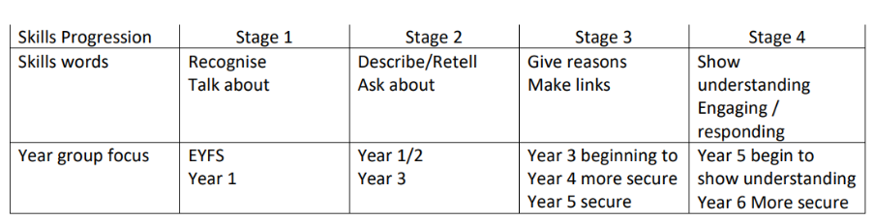

7) Tracking Data
At the end of each branch every child will be assessed against the expected outcomes (RED) using the Ways of Knowing statements. This will show whether the individual is working towards expected, expected or above. This assessment will then be fed into the whole class tracking system similar to how we track Maths and English. Assessment is based on teacher assessments, observations, work in books and moderated work. This will then be collated by the RE coordinators and fed back to teachers. Through this, teachers can then plan the next term’s lessons to enable all children to make progress. Data also analysed at the end of the year to make sure it is in line with the data from maths and English.
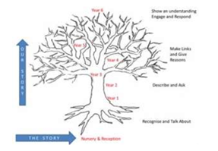

8. Reporting
Reporting in R.E is an integral part of teaching and is instrumental to the learning process. There are four dimensions to reporting in R.E.
• It provides feedback to pupils on their achievements and progress.
• It informs colleagues of the achievement of pupils and areas studied by the class.
• It informs parents of children’s progress and achievement.
• It informs governors, parish and external agencies about the R.E provision at Holy Rosary school. The process of reporting includes end of year reports, parents’ evenings, lists of topics covered and dialogue with relevant parties. In line with Archdiocese recommendations, Religious Education is reported first in the pupils’ end of year report. As well as this, parents are encouraged and welcome to enquire about the progress and achievements of their children.

9. Evaluation of Learning
Evaluation of learning is rooted in a rigorous monitoring process at Holy Rosary, linked to the SIP and the CSED. The monitoring of teaching and learning- an integral and on-going cyclical process- ensures the standards achieved in RE are in line with those of other subjects. Monitoring is carried out by the Headteacher, Deputy Headteacher and RE Leads. It can take the form of lesson observations; drop-ins; learning walks; scrutiny of work and discussions with staff and pupils. Monitoring is also a shared process whereby staff attend a Branch Planning meeting at the start of each half term to discuss scripture, learning objectives and activities; discussion here supports staff with subject knowledge and also helps ensure there is progression across year groups. Staff share examples of pupils’ work to celebrate and generate ideas together.
The children’s learning is continuously assessed by the teacher through their contributions to class discussions and the production of written work / annotated or scribed work. Work is marked regularly with constructive comments included where appropriate. This work is moderated both internally at staff meetings and externally during cluster meetings. This ensures the high quality of learning is consistent through year groups and cluster schools. Children have the opportunity to evaluate their own learning in Religious Education informally in lesson discussions and through our metacognitive approach, which underpins learning in all subjects across the curriculum. Teachers and RE leaders can discuss pupils’ feedback and evaluation of teaching and learning in religious education through the use of Pupil Voice. Children’s responses are then fed back to staff, any changes discussed and implemented, and good practice shared.

11. Continuous Professional Development
At the start of each half term, we have a staff meeting designated as a Branch Planning meeting. In this time, teachers can gather to look at the RED topic overviews, schemes of work and possible activities for the forthcoming branch. They can discuss the meaning of scripture, share ideas and seek advice from colleagues. This forms practical support for teachers from RE Leads, experienced teachers as well as SLT and each other.
The Headteacher and the RE Leads receive the Archdiocese Calendar and monitor this regularly to identify opportunities for staff CPD from the programme provided; they will ensure training is attended by the most appropriate member of staff. Staff who have attended training are given time to feed back and share information at the next staff meeting where appropriate. CPD in RE as well as across the curriculum, is sought to address needs identified in the SIP/CSED; to address needs arising from monitoring and scrutiny and to support staff where teachers have expressed an interest or a need themselves.

12. Staff Induction
All school staff (teachers; teaching assistants; lunchtime supervisors; student teachers) and volunteers/work experience students receive a formal induction interview with a member of SLT when they start at the school. This outlines routines, expectations and specific information and policies. Student teachers and students are introduced to their mentors and ITT lead and all QA and course requirements agreed with the ITT provider are followed.
ECTs are enrolled on the ECF programme through the Rainbow Hub and with the DfE. They are assigned a trained mentor and are given the designated non-contact time as outlined in the ECF. Each term, meetings are held with the Induction Tutor to check on progress with the Teachers’ Standards and to complete the relevant termly reviews for the DfE.
Supply teachers are given a tour of the school and are given a brief induction to the school where behaviour and support expectations are shared. A ‘Guidance for Supply Teachers’ sheet is given to them in the Class Information Files which are left on the teacher’s desk in every classroom. The Class Information Files share key information regarding SEN D or medical needs for the pupils in each class, so the teacher is aware of the need to adapt learning and behaviour strategies.

13. Staff Communication
The school website shares policy documents and key information for staff, parents and visitors.
The Headteacher writes a weekly Newsletter which summarises events that week and adds forthcoming dates for the diary.
A weekly briefing is held for all staff (optional for TAs) every Friday morning in the staff room. Briefing notes are made during the meeting and are posted on the board in the staffroom to read for anyone unable to attend in person.
A staff WhatsApp group has been set up which the Headteacher monitors. They invite all new members of staff to join, if they wish, and remove members of staff after they have left. There is also a separate Lunchtime Supervisors WhatsApp group to keep them informed and updated. In addition, separate meetings are held by SLT with lunchtime supervisors and TAs to give them the opportunity to discuss practice and air any concerns.
All teachers and TAs are given a staff email address and information can be shared via that or on the Staff Channel on Teams.
Teachers attend weekly staff meetings for information sharing and CPD.

14. Resources- Staff Members
Teachers who teach RE
Teacher | Year Group | CCRS/RE responsibility
Gemma Oldfield | Nursery | CCRS; Prayer and Liturgy Lead; Live Simply
Joanne Lund | Nursery, Reception | Eco/Climate Lead-Live Simply
Roz McDonald | Reception
Sarah King | Reception- | EYFS Lead- Assistant Headteacher  RE Lead  CCRS pending
Kathryn Hornblower | Year 1 | CCRS pending
Olivia O’Toole | Year 1
Thomas Williams | Year 2 | CCRS pending
Helen Wall | Year 2 | RSE Lead
Laura Middleton | Year 3
Jess Stephenson | Year 3 | ECT
Aiofe Galvin | Year 4 | CCRS
Elise McCarthy | Year 4 | CCRS
Andrew Walker | Year 4 | CCRS pending
Helen Walker | Year 5 | CCRS pending
Michael Bain | Year 5 | CCRS pending
Lauren Davies | Year 6 | CCRS pending
Julia Stanley | Year 6
Claire Spalenice | PPA cover/PSHE | SENDCo; CCRS
Anna Casey | PPA cover | DHT/ RE LEAD; CCRS

15. Resources- Teaching
Golden boxes- each class has a golden box of resources including:
Focus tables- each class a cross, a Bible and a candle; in addition, each class has a ‘collective worship’ box with fabric and artefacts to enhance focus tables Bibles- each year group has a set of at least 30 Bibles
School prayer collections- a prayerbook containing all the prayers children should know from ‘To Love You More Dearly’ are kept on the class focus area.
Resource boxes are stored in the classrooms. Class teachers are responsible for maintaining resources
Additional resources:
White tablecloth; material in different colours for the liturgical year; artefacts; plants; candles; resources for the Easter Gardens; pictures; sets of rosary beads; nativity sets; pebbles and shells, prayer tree... are stored in the tall cupboard in the photocopying room
There is a separate cost centre allocation in the school budget made for RE.

16. Relationship of Religious Education to the whole curriculum
We have a Prayer and Liturgy Policy which outlines context, requirement, responsibilities, an overview of provision, resourcing, training, monitoring and evaluation and review opportunities. This is available to see on our website.
It also includes where our school curriculum provides opportunities for spiritual and moral development; away days and retreats; how we make links with parents, parish and local community.
We also track where RE naturally links to core and foundation subjects across the school including Art, IT etc... RSE links with RE and PSHE, as well as the wider curriculum, are also tracked. SEN provision considerations, metacognitive strategies and equal opportunities underpin RE as well as our broad and balanced curriculum.

17. Catholic Self Evaluation Document
Section 48 Inspection report is available on our website.
CSED

18. Evaluation of RE Handbook
The Handbook will be reviewed in July 2027, with particular attention to the roll out of the RED to years 5 and 6 and to acknowledge changes to school procedures and provision for prayer and liturgy and whole-school celebrations.

